Name of the Student: G. Manasa | Academic Year: 2025-26
Student Registration Number: 241U1R3007 | Year & Term: II & II
Study Level: UG | Class & Section: CSE(DS)-2A
Name of the Course: Design Thinking | Name of the Instructor: Dr. K. Gayatri Devi
Name of the Assessment: Reflective Lab Journal-6 | Date of Submission: 23/11/2025

Reflective Lab Journal-6
- Point of View (POV)
(POV Formula: User + Need + Insight) POV Based on “5 Whys”:
Campus users need a smart and digital ID system because the current manual ID card causes delays, repeated checking, errors, and safety problems, making daily activities slow and frustrating.
- Insights (from Space Saturation)
- Campus processes are slow because everything is checked manually, which leads to long queues and wasted time.
- Students feel irritated because they have to show their ID card multiple times due to systems not being connected.
- Teachers and students lose class time because attendance is taken manually in every period.
- Payments in the canteen are delayed because students depend on cash and manual billing.
- Staff face difficulties with manual entries in the library and labs, which causes errors and slows down student movement.
- Peak-hour crowding happens because the system is not automated and campus movement is poorly organized.
- Students feel unsafe and worried because lost ID cards cannot be blocked or tracked, increasing security risks.

3. How Might We (HMW) Questions
(4Ws = Who, What, Where, Why)
Based on the 4Ws:
- Who: Students, teachers, staff
- What: Facing slow, repetitive, manual ID-based tasks
- Where: Gate, classes, library, labs, canteen
- Why: ID system is not smart or multi-functional
Here are the HMW questions that come from each element:
From WHO (users having problems)
- How might we make campus activities easier for students?
- How might we reduce workload for teachers and staff?
- How might we support non-teaching staff who handle entry and checking?

From WHAT (the problem itself)
- How might we replace the basic ID card with a smart card?
- How might we combine attendance, entry, and payments into one system?
- How might we reduce the need for multiple apps or cards?
From WHERE (places where problems happen)
- How might we speed up entry at the main gate?
- How might we make library and lab access faster?
- How might we reduce crowding at canteen and classrooms?
From WHY (reason behind the problem)
- How might we remove manual checking to save time?
- How might we avoid repeated ID checks everywhere on campus?
- How might we reduce manual errors caused by the old system?
General HMW from 4Ws
- How might we make all campus activities flow smoothly?
- How might we improve speed and convenience for all users?
- How might we create a single smart ID solution for all campus needs?

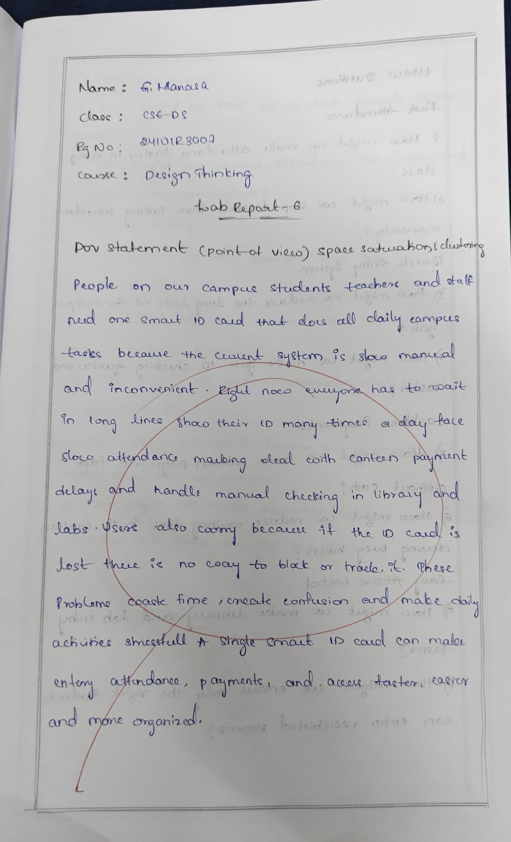

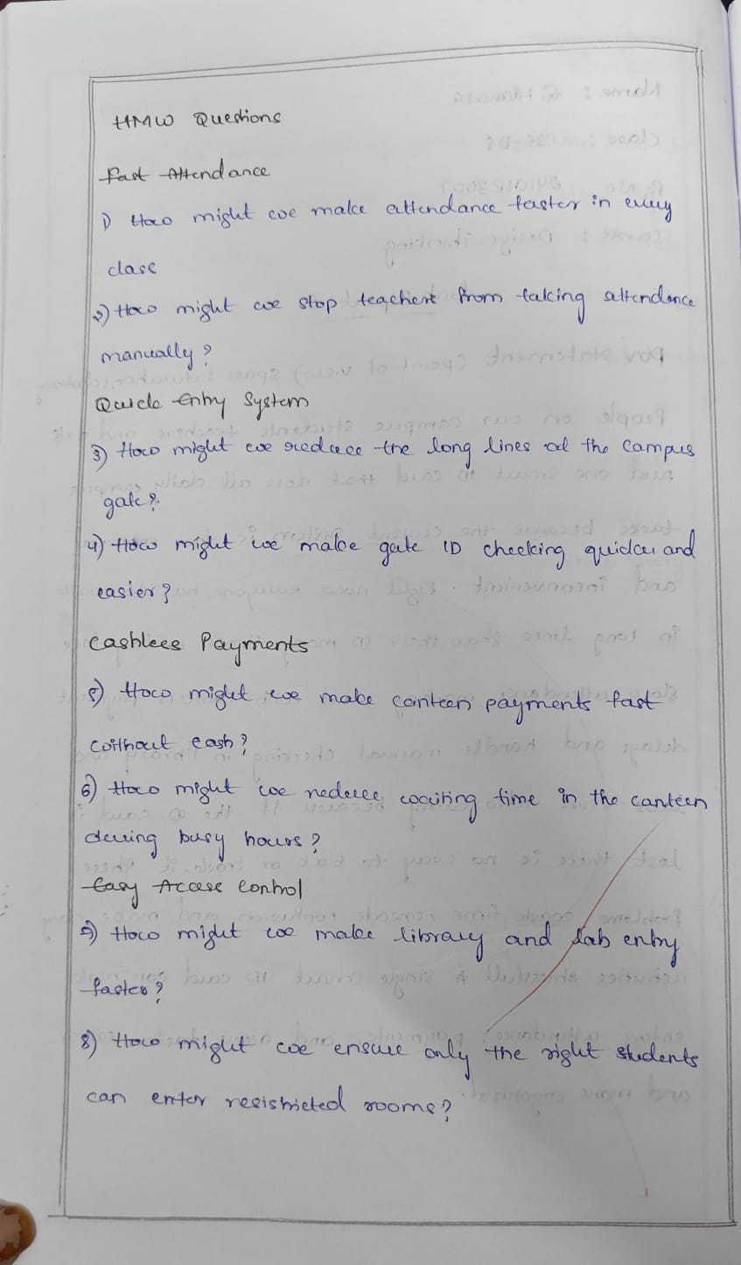

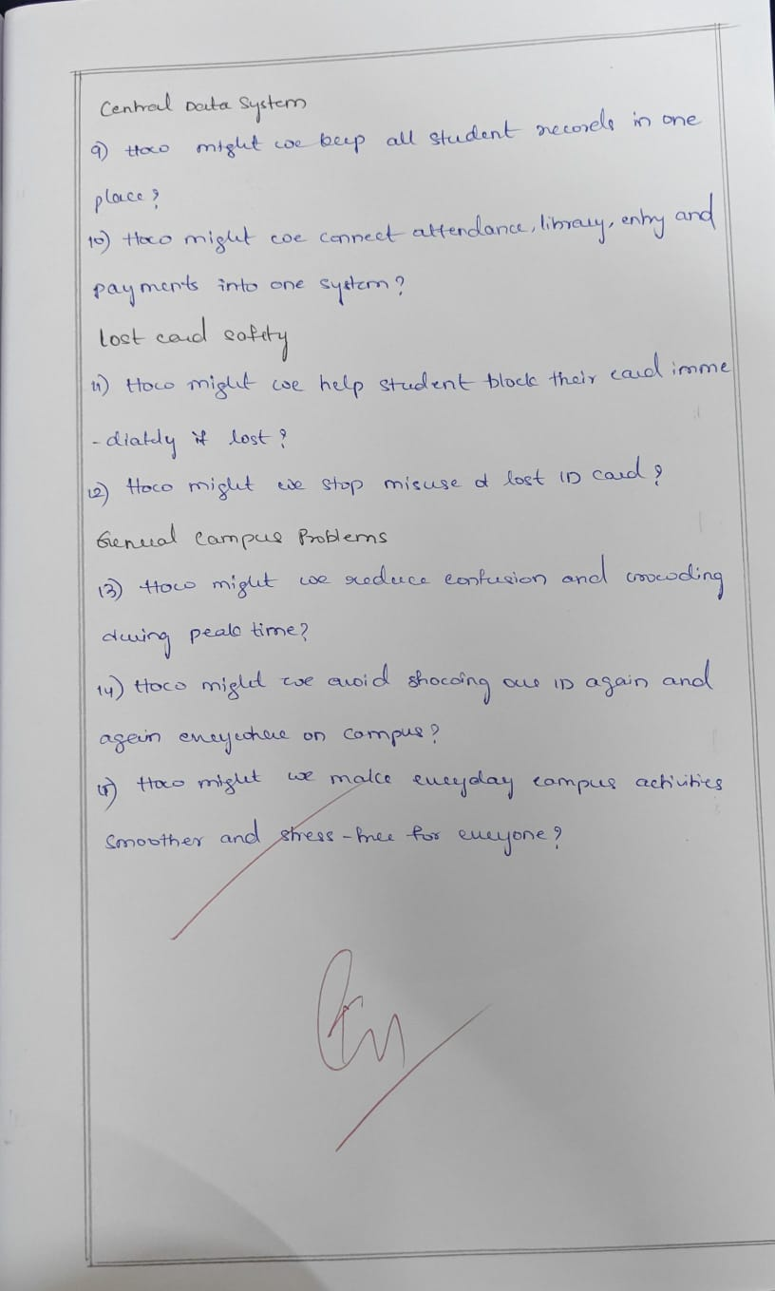

---THANK YOU---

